Bash scripting Tasks

1.To check whether the directory is available is not.

Firstly listing out my files and directories using ll command

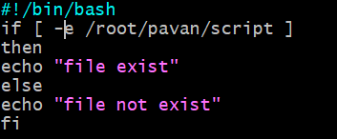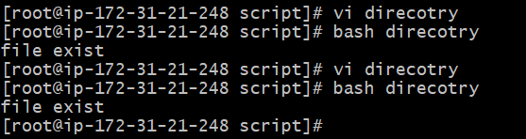

2. Create a bash script which will create multiple files.

Created a file vi multiple files

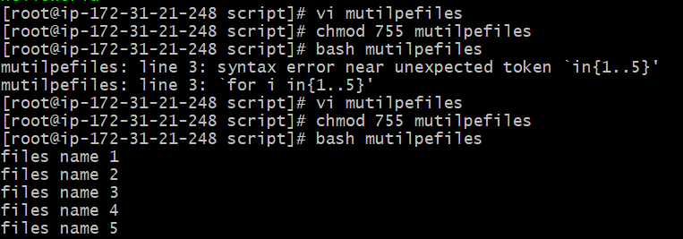

3.Create a bash script to install nginx in ec2 server

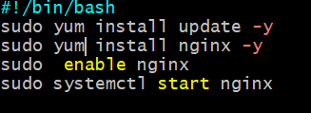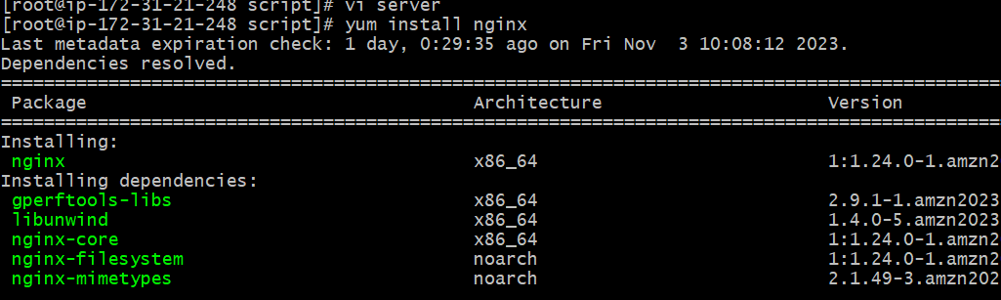4.Create a bash script to take backup of a directory.I hae created a file name vi backup.sh

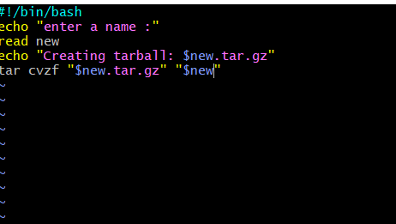

calculator

ca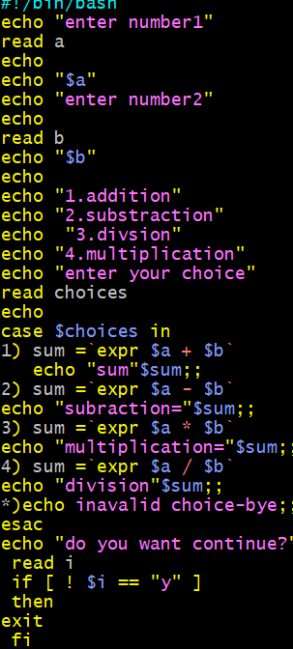

5.Create a bash script to install Apache Tomcat in ec2 server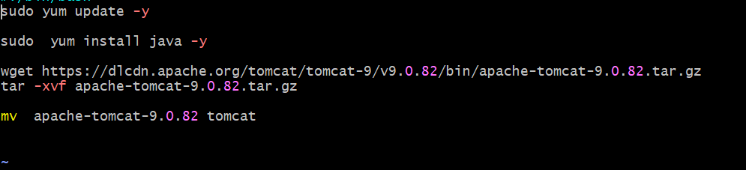

Firstly we have to download Apache tomcat version

And then check for its existence

Create a bash script to check list if nginx service is running or not,if not running then script should start the service.

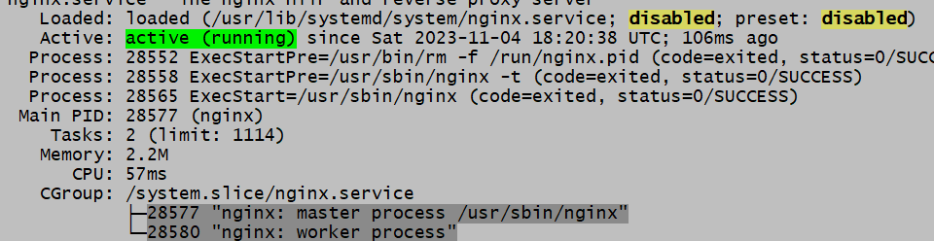

As of now my nginx is running

8) Create a bash script to check if directory is avaialble or not,if not then create a directory.